SEO Metadata
- Focus Keyword: best web design company in Bangalore
- Meta Title: Best Web Design Company in Bangalore (2026 Guide) | Brewing Ideaz
- Meta Description: Looking for the best web design company in Bangalore? Learn what to evaluate — UX, design quality, process, pricing & red flags — before you hire.
- URL Slug: /best-web-design-company-in-bangalore

Secondary Keywords
- web design company in Bangalore
- website design company in Bangalore
- web design services in Bangalore
- website development company in Bangalore
- professional web designers in Bangalore
- custom website design in Bangalore
- UI/UX design company in Bangalore
- responsive web design services
- website redesign services in Bangalore
- Brewing Ideaz Bangalore

Best Web Design Company in Bangalore: A Complete Guide to Choosing the Right Partner
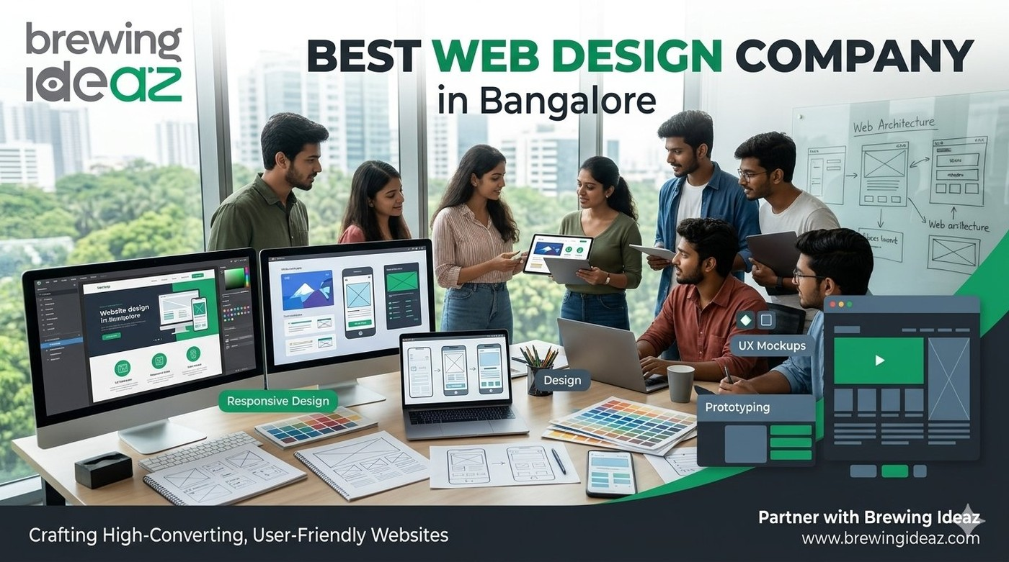
Bangalore’s competitive market means your website is often the first serious impression a potential customer or investor forms of your business. Hundreds of studios claim to be the “best web design company in Bangalore,” but design quality, technical execution, and strategic thinking vary widely.
This guide helps you evaluate partners with a clear checklist.

What “Best” Means in Web Design
A strong web design company delivers more than an attractive interface. It should understand your users, business goals, and conversion paths, then create a site that is visually cohesive, technically solid, fast, mobile-friendly, and easy to maintain.
The best partners combine UX research, visual design, front-end development, and clear communication throughout the project.
Fit matters. An agency that specialises in marketing websites for startups may not be ideal for a complex SaaS product interface, and vice versa.

Key Factors to Evaluate Before Hiring a Web Design Company

1. Portfolio Quality and Relevance
Look at live websites, not just mock-ups. Check the mobile experience, loading speed, visual consistency, and how the design supports the business goal.

2. UX and Research Process
Strong teams ask about users, customer journeys, and success metrics before designing screens.

3. Technical Capability
Confirm responsive website design, performance optimisation, accessibility basics, clean hand-off to developers, and full-stack delivery if required.

4. Project Process and Timelines
Understand discovery, design, development, testing, and launch phases, and how feedback and approvals are handled.

5. Post-Launch Support
Clarify bug fixes, training, ongoing maintenance options, and the process for requesting future updates.

6. Communication and Ownership
Confirm who manages the project, how often you can expect updates, and ownership of design files, source code, content, and CMS training.

Why Bangalore-Based Web Design Companies Often Have an Edge
Local teams share working hours with most Bangalore clients, understand the local startup and enterprise ecosystem, and are used to iterating quickly with product and marketing stakeholders.

Questions to Ask Before You Hire
- Can you walk me through your discovery and design process?
- Do you have live case studies similar to my project type or industry?
- Who will design and who will develop, and how do they collaborate?
- What does the typical timeline and revision process look like?
- What support do you provide after launch?
- Will I own the design files and website source code?
- How do you ensure the website works across mobile devices?
- What tools and technologies will you use?
- How do you test website performance and accessibility?
- What are the ongoing maintenance costs, if any?

Red Flags to Watch For
Be cautious of companies that show only static mock-ups with no live sites, promise extremely short timelines for complex projects, cannot explain their process, or offer prices far below market without a clear scope. Other warning signs: poor communication during the sales process, unclear deliverables, no defined revision or approval process, unclear ownership of design files or code, no testing/QA process, and no explanation of post-launch support.

How to Choose the Right Web Design Company for Your Business
- Define Your Website Goals — business website, e-commerce store, portfolio, landing page, or web application.
- Identify Your Design and Technical Requirements — features, integrations, responsive requirements, CMS, accessibility.
- Review Relevant Portfolios — live websites, design quality, usability, mobile responsiveness.
- Compare Proposals — scope, deliverables, timelines, pricing, revision policies, post-launch support.
- Agree on Ownership and Communication — responsibilities, approvals, file ownership, maintenance expectations.

Final Thoughts
The best web design company in Bangalore for your business is the one that understands your users and goals, designs with both aesthetics and performance in mind, and delivers a site you can maintain and grow.

Ready to Discuss Your Website Project?
Brewing Ideaz is based in Bengaluru, on Sarjapur–Marathahalli Road, with a branch office in Kolkata.
Call or WhatsApp: +91 62915 47048 Email: info@brewingideaz.com

30 Frequently Asked Questions About Web Design Company in Bangalore
- What is a web design company? A web design company creates and designs websites based on a business’s goals, target audience, and requirements. Services may include visual design, UX, responsive layouts, and development.
- How do I choose the best web design company in Bangalore? Evaluate the company’s portfolio, design expertise, technical capabilities, project process, pricing, communication, and post-launch support.
- What services does a web design company provide? Website design, responsive design, UI/UX design, website redesign, landing page design, and website development.
- How much does a web design company in Bangalore charge? Pricing depends on complexity, features, design requirements, technology, and project scope.
- Why should I hire a professional web design company? To create a website aligned with your business goals that provides a consistent user experience across devices.
- What is the difference between web design and web development? Web design focuses on layout, visual appearance, and UX. Web development implements the design and builds the functionality.
- What is UI/UX design? UI design focuses on visual and interactive elements. UX design focuses on usability, navigation, and user needs.
- Why is responsive web design important? It allows a website to adapt to different screen sizes and devices.
- What is website redesign? Updating a website’s appearance, structure, UX, or functionality to better meet current needs.
- How long does it take to design a website? Depends on complexity, pages, features, content readiness, feedback, and testing.
- What should I prepare before hiring a web design company? Business goals, target audience, requirements, branding assets, content, budget, and timeline.
- What is a website wireframe? A simplified visual layout showing page structure, content placement, navigation, and key elements.
- What is a website prototype? An interactive or visual representation of a website demonstrating user flows before final development.
- What is the role of user experience in web design? How easily and effectively visitors can navigate and complete their intended tasks.
- Why is website loading speed important? A fast-loading website contributes to a better overall user experience.
- What is mobile-friendly web design? Design that ensures usability on smartphones, with readable text and accessible navigation.
- What is accessibility in web design? Designing so people with different abilities can use the site, including keyboard navigation and assistive technologies.
- What is a content management system (CMS)? Software that lets users create, manage, and update content without editing code directly.
- What is the difference between a custom website and a template-based website? A custom site is built to specific requirements; a template site uses a pre-designed layout with limited customisation.
- What is website maintenance? Ongoing updates, backups, security checks, bug fixes, and content updates.
- Will I own my website after the project is completed? Depends on the contract — clarify ownership of code, design files, content, domain, and third-party assets.
- What is included in a web design project? Discovery, wireframes, visual design, responsive layouts, development, testing, launch, and training, depending on scope.
- How do I evaluate a web design company’s portfolio? Review live websites, mobile usability, visual consistency, navigation, performance, accessibility, and relevance.
- Can a web design company help with SEO? Yes — SEO-friendly structures, responsive layouts, and clear navigation; ongoing SEO may require separate services.
- What is conversion-focused web design? Design aimed at helping visitors complete desired actions, such as submitting a form or making a purchase.
- What is the importance of website navigation? Clear navigation helps visitors find relevant information with less effort.
- What should I include in a web design contract? Scope, deliverables, timelines, fees, payment terms, revision limits, ownership, and post-launch support.
- What are common mistakes to avoid when hiring a web design company? Choosing solely on price, ignoring mobile usability, failing to define scope, overlooking ownership terms, neglecting post-launch support.
- Does a web design company guarantee website performance? A company may agree to specific technical requirements, but actual performance also depends on hosting, content, and integrations.
- How can I contact Brewing Ideaz for web design services in Bangalore? Call or WhatsApp +91 62915 47048 or email info@brewingideaz.com.

